AI Assisted Coding
Assignment -7.1
B.Tejaswi
2303A52123
Batch-40

Task Description #1 (Syntax Errors – Missing Parentheses in Print
Statement)
Task: Provide a Python snippet with a missing parenthesis in a print
statement (e.g., print "Hello"). Use AI to detect and fix the syntax
error.
# Bug: Missing parentheses in print statement
def greet():
print "Hello, AI Debugging Lab!"
greet()
Requirements:
• Run the given code to observe the error.
• Apply AI suggestions to correct the syntax.
• Use at least 3 assert test cases to confirm the corrected code
works.
Expected Output #1:
• Corrected code with proper syntax and AI explanation.
Prompt:
#Find the syntax errors in this Python code and explain what is wrong.
Comments:

Correct this Python code so it runs without errors in Python 3 with proper indentation.
Modify this function so it returns the message instead of only printing it, making it easier to test.
Add at least three assert test cases to verify that this corrected function works properly.

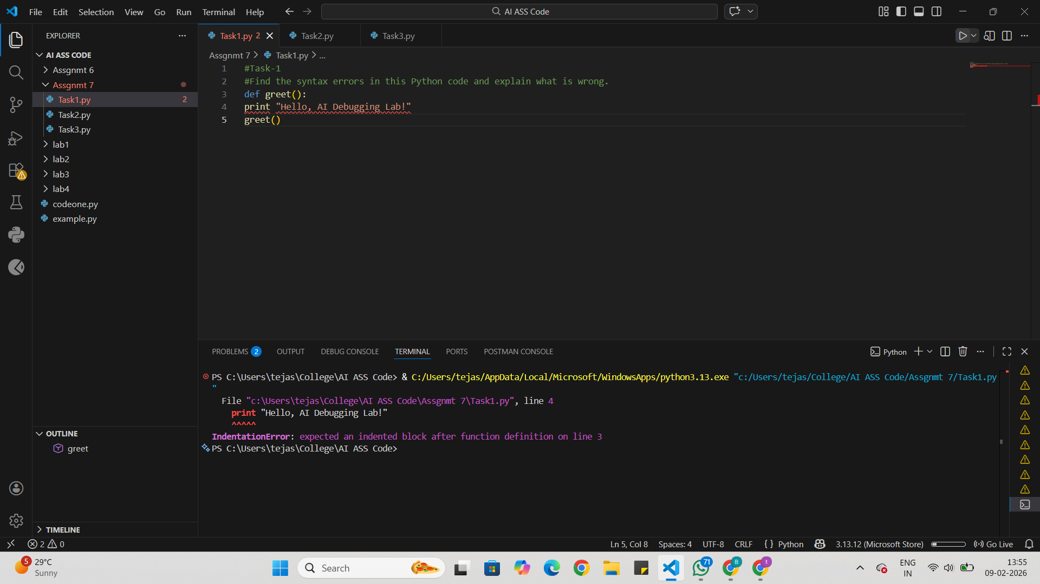
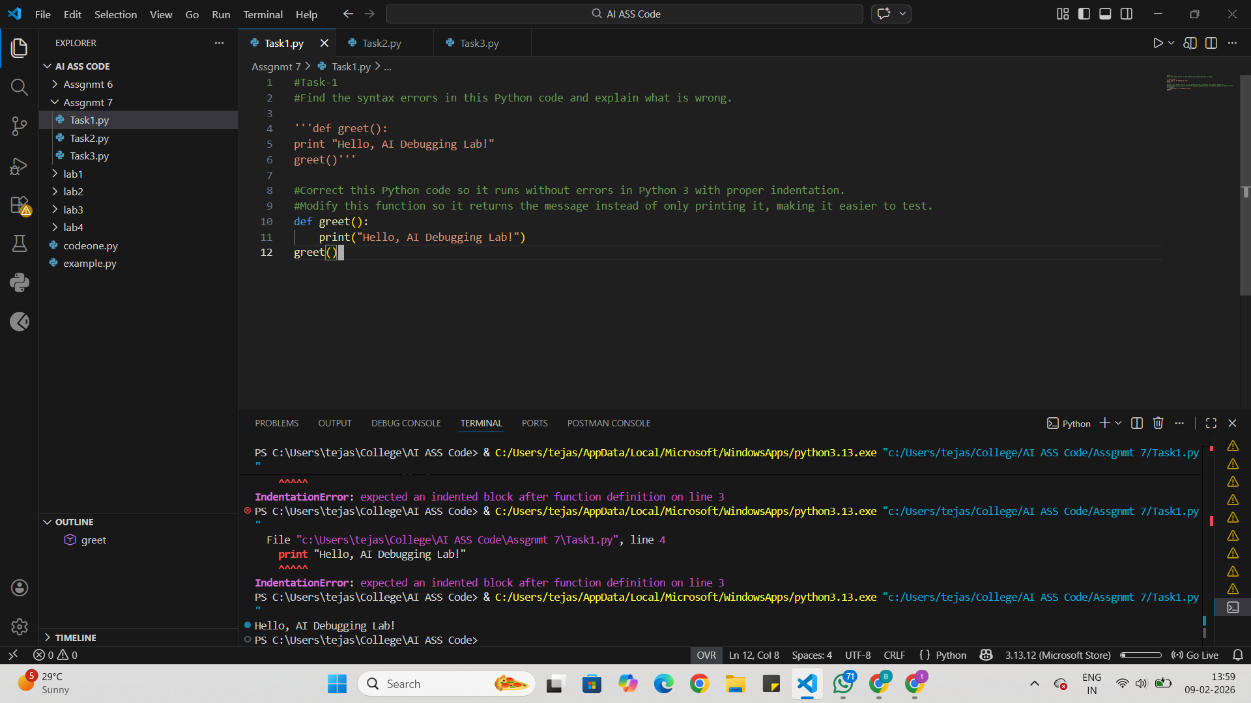
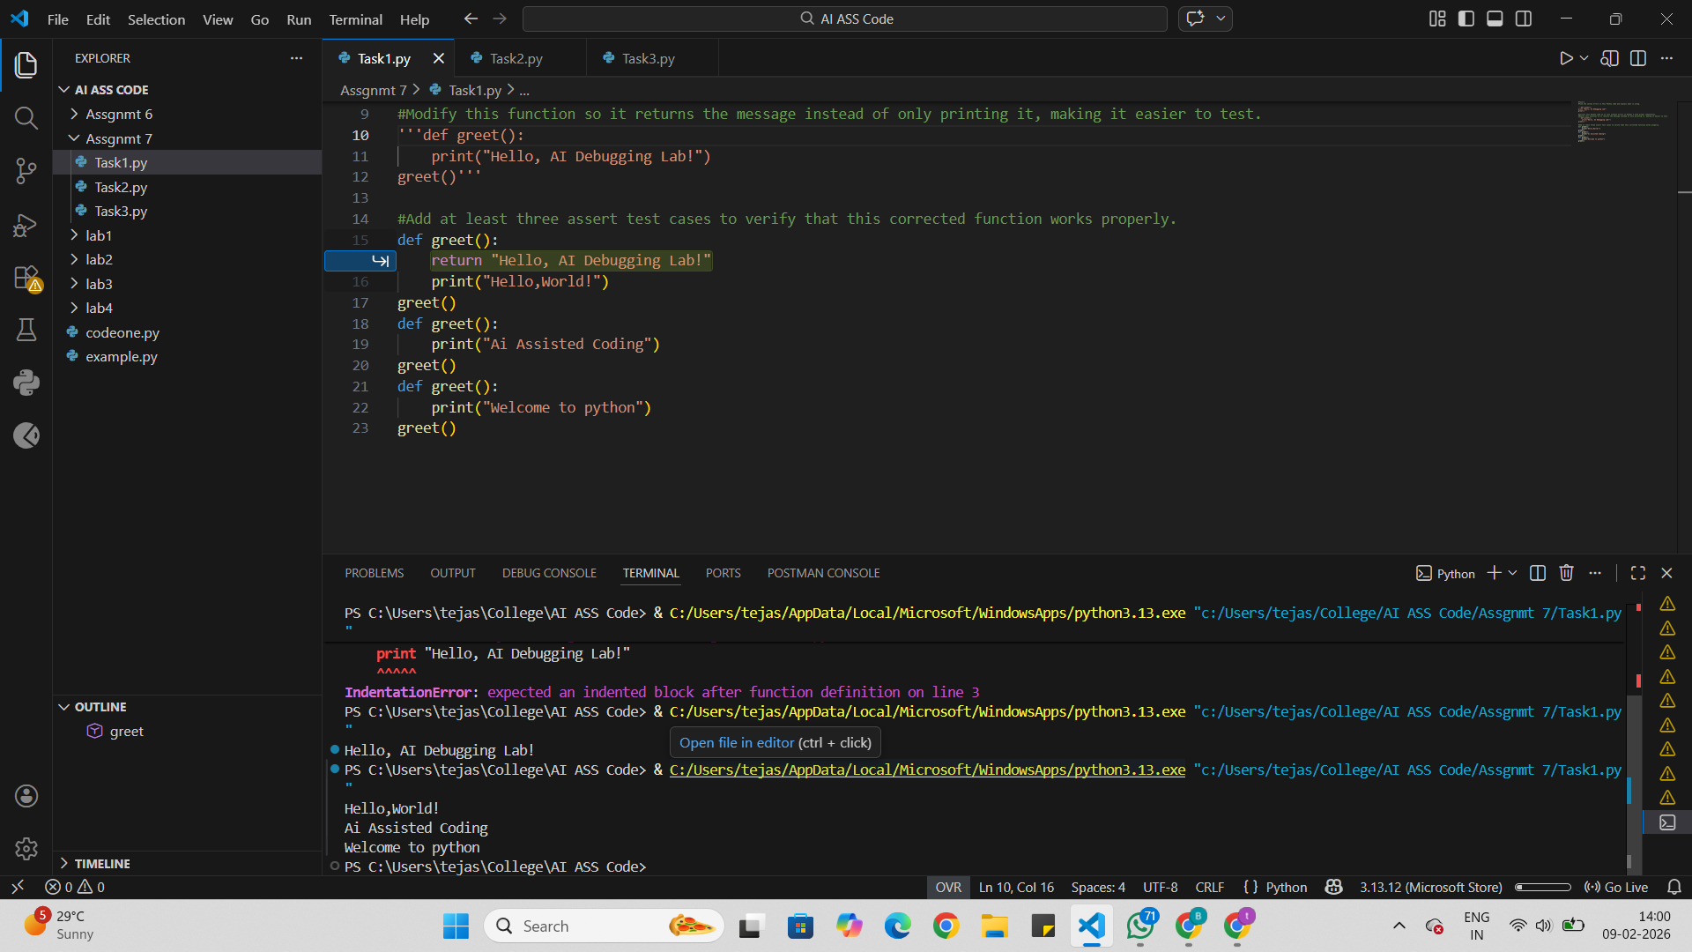

Task Description #2 (Incorrect condition in an If Statement)
Task: Supply a function where an if-condition mistakenly uses =
instead of ==. Let AI identify and fix the issue.
# Bug: Using assignment (=) instead of comparison (==)
def check_number(n):
if n = 10:
return "Ten"
else:
return "Not Ten"
Requirements:
• Ask AI to explain why this causes a bug.
• Correct the code and verify with 3 assert test cases.
Expected Output #2:
• Corrected code using == with explanation and successful test
execution.

Prompt:
find the incorrect condition in an If statement.
Comments:
Correct this Python code so it runs without errors in Python 3 with proper indentation.
Modify this function so it returns the message instead of only printing it, making it easier to test.
Add at least three assert test cases to verify that this corrected function works properly.
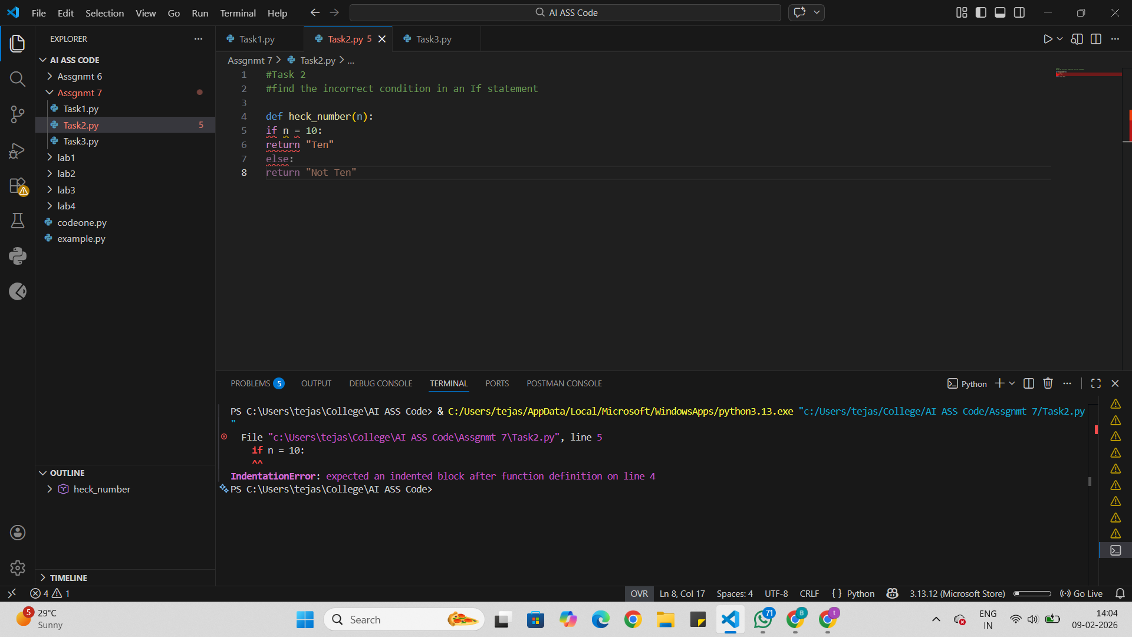
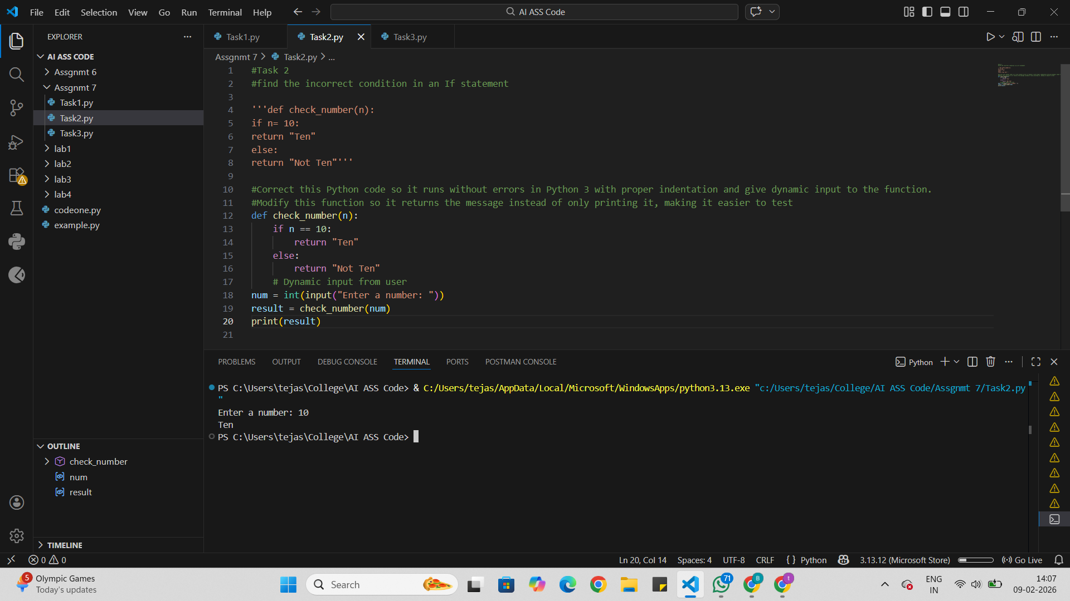

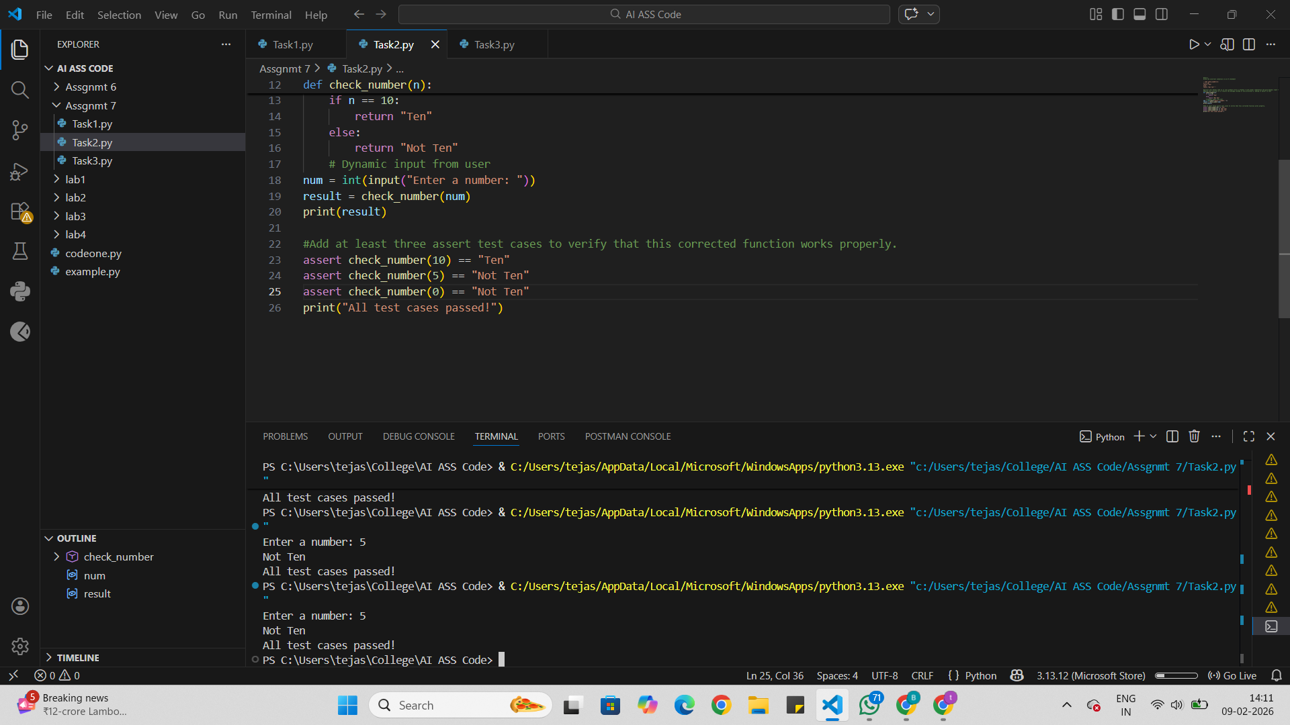

Task Description #3 (Runtime Error – File Not Found)
Task: Provide code that attempts to open a non-existent file and
crashes. Use AI to apply safe error handling.
# Bug: Program crashes if file is missing
def read_file(filename):
with open(filename, 'r') as f:
return f.read()
print(read_file("nonexistent.txt"))
Requirements:
• Implement a try-except block suggested by AI.
• Add a user-friendly error message.
• Test with at least 3 scenarios: file exists, file missing, invalid
path.
Expected Output #3:
• Safe file handling with exception management.

Prompts:
# Runtime Error – File Not Found
Comments:
Correct this Python code so it runs without errors in Python 3 with proper indentation.
Modify this function so it returns the message instead of only printing it, making it easier to test.
Add at least three assert test cases to verify that this corrected function works properly.
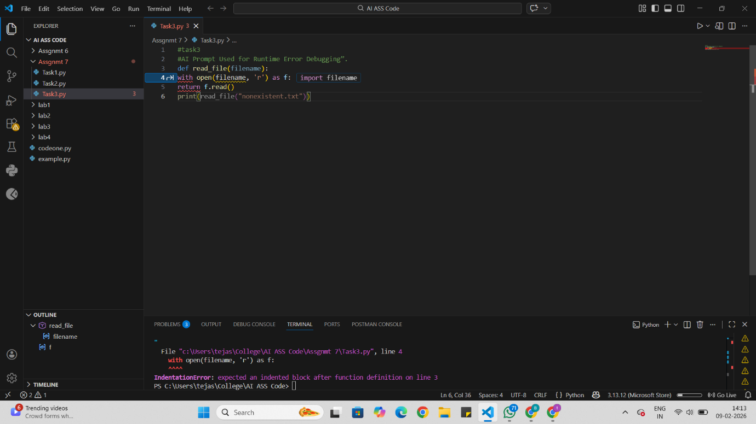
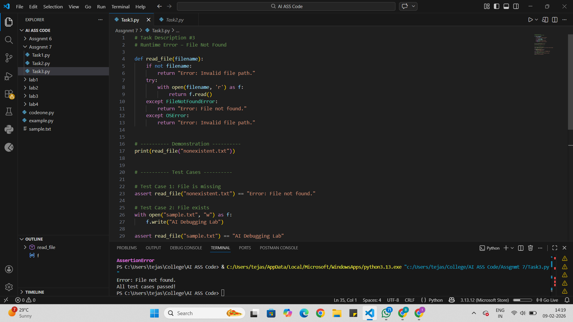

Task Description #4 (Calling a Non-Existent Method)
Task: Give a class where a non-existent method is called (e.g.,
obj.undefined_method()). Use AI to debug and fix.
# Bug: Calling an undefined method
class Car:
def start(self):
return "Car started"
my_car = Car()
print(my_car.drive()) # drive() is not defined
Requirements:
• Students must analyze whether to define the missing method
or correct the method call.
• Use 3 assert tests to confirm the corrected class works.
Expected Output #4:
• Corrected class with clear AI explanation.
Prompts:
Bug: Calling an undefined method
Comments:
Correct this Python code so it runs without errors in Python 3 with proper indentation.
Modify this function so it returns the message instead of only printing it, making it easier to test.
Add at least three assert test cases to verify that this corrected function works properly.
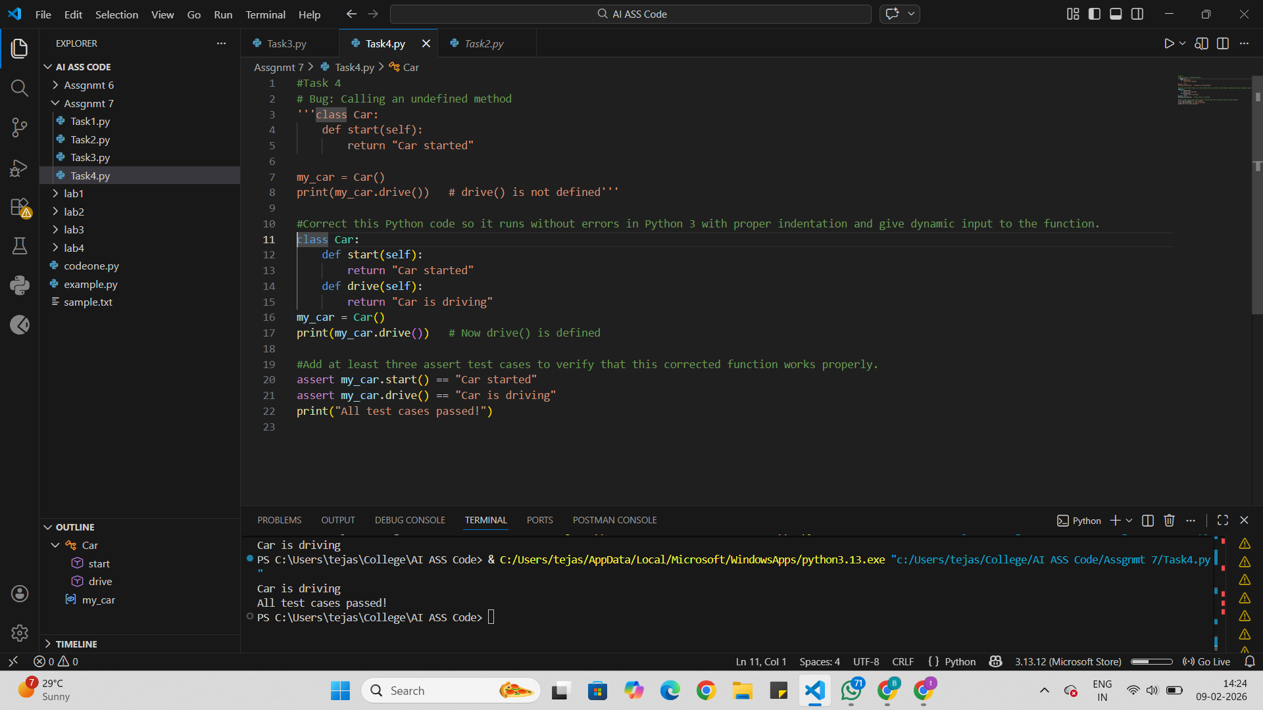

Task Description #5 (TypeError – Mixing Strings and Integers in
Addition)
Task: Provide code that adds an integer and string ("5" + 2) causing
a TypeError. Use AI to resolve the bug.
# Bug: TypeError due to mixing string and integer
def add_five(value):
return value + 5
print(add_five("10"))
Requirements:
• Ask AI for two solutions: type casting and string
concatenation.
• Validate with 3 assert test cases.
Expected Output #5:
• Corrected code that runs successfully for multiple inputs.
Prompts:
Bug: TypeError due to mixing string and integer

Comments:
Correct this Python code so it runs without errors in Python 3 with proper indentation.
Modify this function so it returns the message instead of only printing it, making it easier to test.
Add at least three assert test cases to verify that this corrected function works properly.
